Project Design Phase Problem – Solution Fit Template

Date | 27 Jan 2026
Team ID | LTVIP2026TMIDS76986
Project Name | Flight-Booking
Maximum Marks | 2 Marks

Problem – Solution Fit Template:
The Problem-Solution Fit simply means that you have found a problem with your customer and that the solution you have realized for it actually solves the customer’s problem. It helps entrepreneurs, marketers and corporate innovators identify behavioral patterns and recognize what would work and why

Purpose:

Convenient Ticket Reservation – Enables users to search, compare, and book flights easily from anywhere.
Real-Time Availability – Provides up-to-date information on flight schedules, prices, and seat availability.
Secure Payments – Facilitates safe and efficient transactions for booking and cancellations.
Customer Data Management – Stores passenger details to streamline check-in, loyalty programs, and travel history.
Automation and Efficiency – Reduces manual workload through automated confirmations, reminders, and updates.

Template:
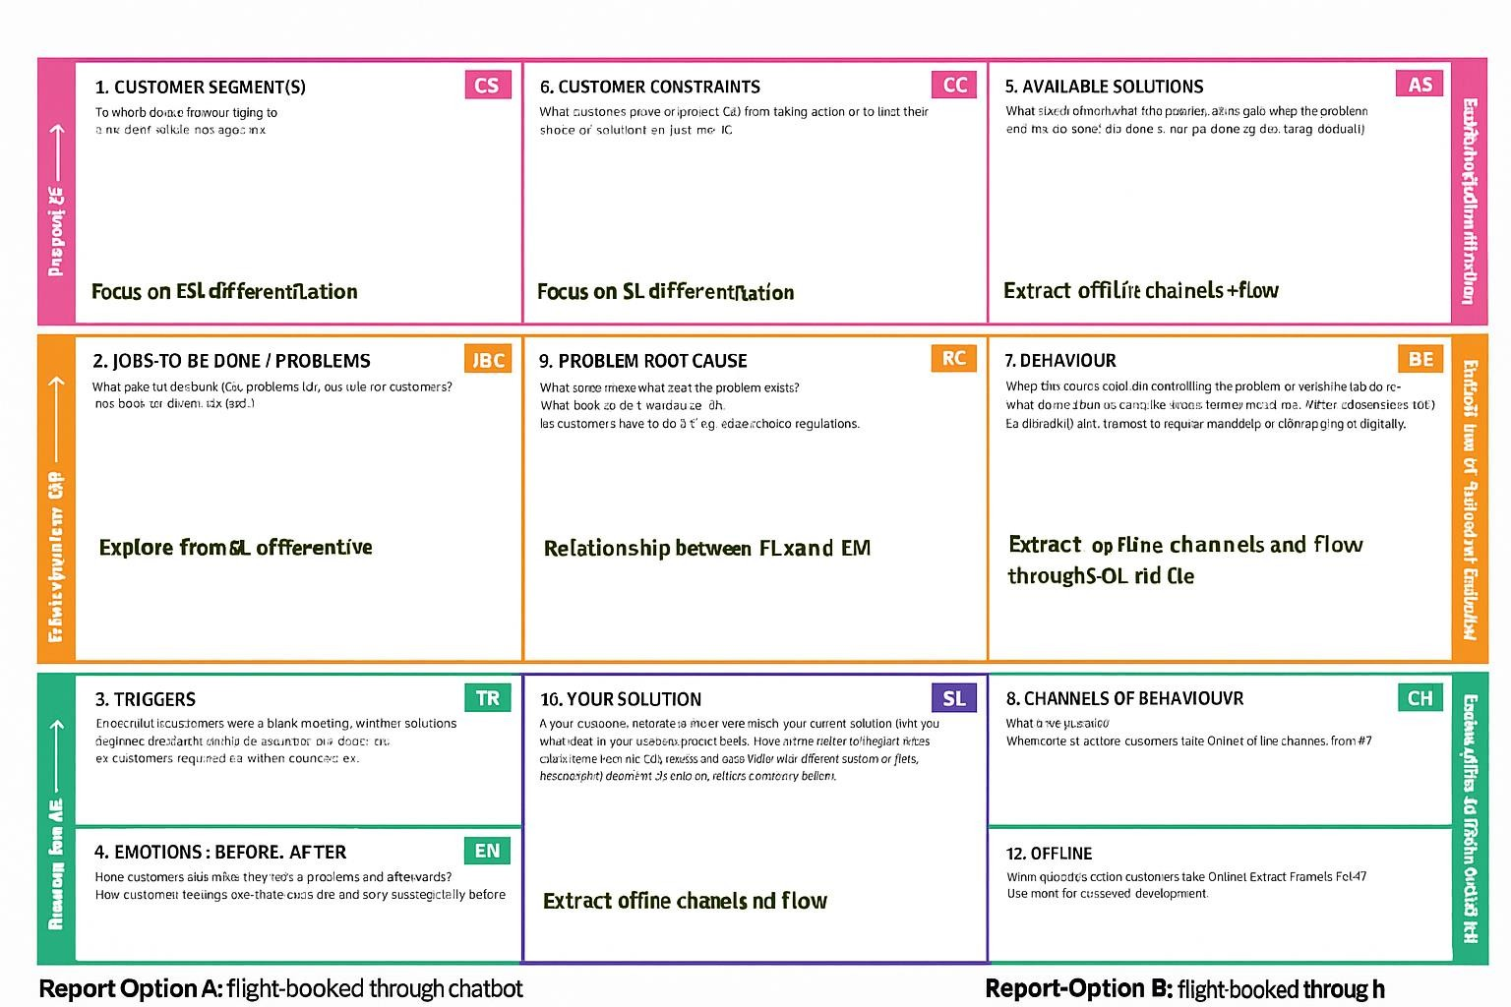

References:
https://www.strategyzer.com/canvas/business-model-canvas
https://medium.com/@epicantus/problem-solution-fit-canvas-aa3dd59cb4fe

